Waterstone Crook Sports Centre
Newport-on-Tay
&
The Dick McTaggart Centre
Dundee

Welcome Pack

2022-23 Session

Welcome New Member

Welcome to Pegasus Gymnastics Club!

Welcome

Firstly, we would like to thank you for joining us here at Pegasus Gymnastics Club.
Our mission is to make Pegasus Gymnastics Club the first choice for potential gymnasts in North East Fife and the surrounding area. We have successfully grown and expanded the Club over the last 15 years and are extremely proud of our gymnasts’ and coaching achievements. We operate a professional yet friendly, stimulating and energetic environment for the children in our care and their wellbeing and health and safety are our utmost priority. We have a strong family focus and are committed to proactively involve parents and carers of our gymnasts wherever possible.

Pegasus Gymnastics Club is divided into 8 sections:

Girls Recreational Gymnastics - this covers all aspects of gymnastics including floor, beam, vault, trampette, tumble and bars. Recreational sessions are available either on Wednesday afternoon 4-6pm (age 5+) OR a Thursday afternoon 4-6pm (age 5+) both at Waterstone Crook Sports Centre. Recreational gymnasts will be expected to take part in our club displays, internal competitions and work towards gaining their Scottish Gymnastics Awards.

Girls Start Squad - this is for girls (aged 5-8) who have shown the potential to progress into one of the squads below. Children are selected to take part in this squad based on their ability and skill level. Start Squad members are to train on Tuesdays 5-7pm or Wednesdays from 4-6pm at Waterstone Crook Sports Centre. Gymnasts will be expected to take part in our club displays as well as internal and external competitions and increasing to 2 sessions per week.

Floor & Vault Squad - for children aged 8 and above. Gymnasts are chosen to take part in this squad either by coach selection based on their skill and ability level or progression through our Start Squad. The Floor & Vault Squad are to train at least twice a week on Monday 6-8pm at McTaggart AND Tuesday 6-8pm at Waterstone Crook. Floor & Vault gymnasts will be expected to take part in our club displays, internal competitions and various Floor and Vault competitions around Scotland.

Floor & Vault Development Squad – Gymnasts progress into this squad from the Floor & Vault squad once a merit has been achieved at a Scottish Gymnastics Floor & Vault Competition and they are deemed an Intermediate floor and vault gymnast. It can also be a pathway out of the grade squad if a grade has yet to be sat. The Floor & Vault Development Squad are to train at least twice a week on Tuesdays 5-8pm at Waterstone Crook AND Friday evenings from 5-7pm at the McTaggart Centre in Dundee. Floor & Vault development gymnasts will be expected to take part in internal competitions and at various Intermediate Floor and Vault competitions around Scotland.

Grades Squad - the gymnasts selected to train in this squad are selected as they have shown the potential to follow the British Gymnastics National Development Pathway through a Grading system. Selection is made by our coaches based on the Gymnasts ability and skill level on ALL apparatus or through the Start Squad. There are currently 3 sessions a week for the squad gymnasts to attend and those chosen for the squad are expected to attend all 3 of these sessions. The sessions are varied depending upon the grade being sat: Monday 6-8.30pm at the McTaggart Centre, Thursday 4.00-6pm at Waterstone Crook and Friday 5-7pm at the McTaggart Centre, Dundee. Squads are expected to compete in both internal and external competitions as well as work towards their Grade.

Boys Development -. Our boys development section train on Mondays at McTaggart 6-8.30/9pm and Tuesdays 5.30-8pm at Waterstone Crook. All boys are expected to take part in our internal competitions while our boys’ development gymnasts are expected to take part in both our internal competitions and also external Floor and Vault competitions

Display Squad - this section of the club was developed in 2015 and gives our senior Gymnasts the chance to showcase their skills on stage in a choreographed floor routine to music. The Team wowed the crowds with their first ever performance in Ayr at Scottish Gymnastics annual “Gymfest” event in April 2016 and have continued to perform at various Gymfests across Scotland each year. Display gymnasts train on Wednesdays 5-7pm at Waterstone Crook and Fridays 7-9pm at the McTaggart Centre in Dundee. Display Team selection is made by the Team coach.

Pegasaurs preschool programme - started in October 2015 after we were awarded funding from “Awards for All” Big Lottery Fund towards the purchase of new equipment and also the introduction of a preschool programme at the Club. The preschool classes run on Friday afternoons and are for children aged 18mths-5years. There are two structured development groups. 18 months to 3 years which runs from 1-1:45pm and involves parental interaction through the medium of play, the 3-5 year old class runs from 2-2:45pm, there is no parental interaction required in this age group to encourage independent play and nurture social skills through physical activity and fun sessions.

Pegasus Gymnastics Club also run gymnastics camps during the Easter Summer and October school holidays open to both members and non-members. Our squad training continues throughout the holiday periods.

Club Policies & Procedures

Bring a bottle of juice or water (fizzy drinks are not permitted);. A small healthy snack can also be brought along for break time, however, please bear in mind that gymnasts will be active and will only have a few minutes to eat.

** PLEASE BE AWARE ONE OF OUR COACHES HAS SEVERE NUT ALLERGY WHICH REQUIRES THE USE OF AN EPI-PEN
AS MUCH AS NUTS ARE A HEALTHY SNACK WE ASK YOU DO NOT BRING NUTS OR NUT BASED PRDUCT TO CLASS FOR A SNACK OR EAT THEM JUST PRIOR TO ATTENDING**

Long hair should always be tied back neatly and securely for each session. All jewellery should be removed, including earrings, to avoid injury.

Appropriate clothing should be worn to each session attended, this includes leotards, leggings, t-shirts and shorts – jeans or trousers are not suitable as these hinder movement.

Our responsibility for your child/children begins and ends at the start and finish times of each session. Parents/Nominated adults are responsible for their child/children out with these time periods. All children under 10 must be accompanied by a parent/nominated adult both to and from the gym hall. At the end of each session, all children must be signed out by a parent/nominated adult. PGC will not be responsible for your child’s safety beyond the sports hall.

Updates to Privacy Policy

Our full Privacy Policy has been updated following the COVID-19 pandemic a copy will be emailed out for your reference and can also be viewed on request.

Communication

The primary point of contact for the club is our club mobile: 07599 042297. Please use this number to: inform us if your child is unable to attend a planned session, any session queries and any general enquiries. Please note that the Club mobile is not manned 24 hours a day so it is best to contact us via text message and if required a club official will call you back.

In the event of class cancellation by PGC, and to ensure all parents are informed, all contacts stored in the Club mobile phone will receive the same message regardless of the session their child/children.

We also have a Facebook page https://www.facebook.com/PegasusGymnasticsClub?ref=hl which is used for important updates, event announcements and for answering any queries from existing or potential club members. Make sure you find us and like us to provide you with an additional line of communication. Members are also invited to join our Private Members Group which can be accessed through our Facebook Page.

Our Head Coach can be contacted at: claire@pegasusgymnasticsclub.co.uk

For any safeguarding or COVID related issues our Child Protection Officer, Jill Elder can be contacted by email safeguarding@pegasusgymnasticsclub.co.uk or by sending a message through the Club phone.

Please keep your contact details up to date and inform a coach or committee member if your phone/address/e-mail changes.

Fees

Scottish Gymnastics Annual Registration Fee £19 (Recreational) – paid direct to Scottish Gymnastics – please click on following link for full details https://register.british-gymnastics.org/gymnet/register/registerstart

Scottish Gymnastics Annual Registration Fee £43 (Competitive – Grades Squad) – paid direct to Scottish Gymnastics – please click on following link for full details https://register.british-gymnastics.org/gymnet/register/registerstart

Scottish Gymnastics Membership runs from 1st September to 31st August each year. Membership is mandatory for insurance purposes and covers your child for any accidents which may occur. You are legally bound to register your child as without registration no child can participate in club activities.

Pegasus Gymnastics Club Annual Membership Fee £30 (non-refundable)

Session Fees £5 per hour
Grade Squad Session Fees £4.50 per hour (attending 3+ sessions per week)

Sibling Discount:
2 Siblings £30 per child per year (pro-rata if late start)
3 siblings £35 per child per year (pro-rata if late start)
4+ siblings £40 per child per year (pro-rata if late start)

Our Treasurer will distribute fee notes at the beginning of the gymnastics year (August) showing your fees for the full year (to end June) with full payment details.

Payment details and term times are provided on each fee note and payment must be made by standing order or bank transfer on the 1st of each month.

All fees go towards the costs of hiring the sports centres and our coaches’ wages. Any surplus funds are used to help fund/part fund competitions, subsidise club kit, Christmas parties and medals.

If you have any queries regarding fees, please contact our Accounts Officer accounts@pegasusgymnasticsclub.co.uk and please add this email address to your approved contact list to ensure you do not miss any vital communications)

A copy of our Fees & Refund Policy will be distributed with your annual fee note for you to read and retain for future information.

Club Kit

Our Pegasus Club Kit includes either, a sleeveless or long-sleeved leotard for girls (shorts are optional) with leotard and shorts for boys (kingfisher blue/black), team tracksuit (navy zoodie and jog pants) and t-shirt (navy) and a gym bag which all (except leotards) include our club logo and can be personalised to include your son/daughter’s name. Our Grade Squad girls compete in navy leotards.

Here is a picture of some of the girls and boys representing Pegasus in their club leotards!

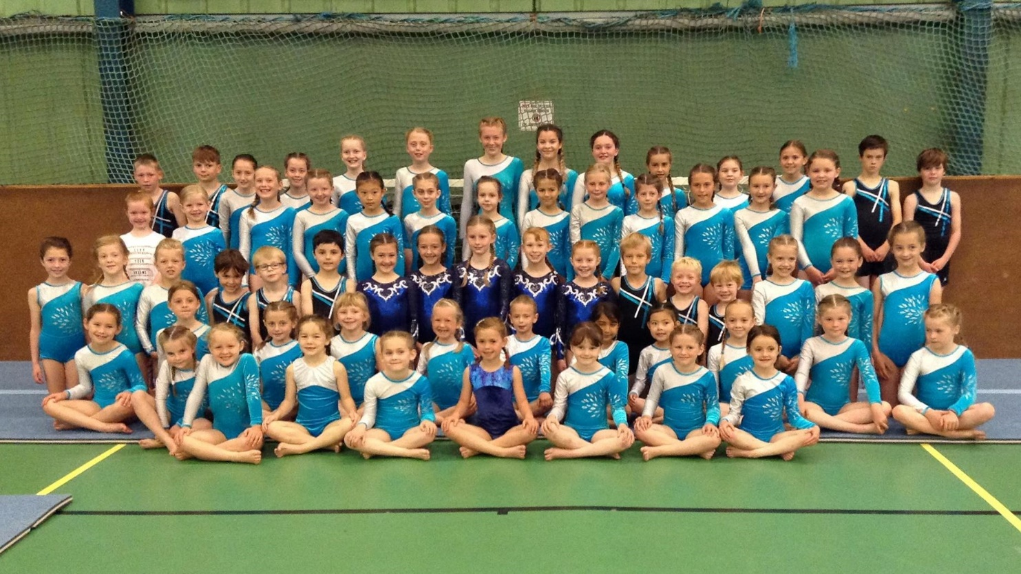

A Club Order Form is available on request (price increase pending). Club Kit orders must be paid for at the time of ordering as we source our kit from an external supplier.

If you wish to place an order, please return your completed order form to the Treasurer along with BACS payment. The Treasurer will then order the items for you. If unsure of sizing, samples can be brought into the club for viewing.

Prices are dependent on size, as follows:

Kit Item | Price Range
Girls Long Sleeve Leotard | £35 to £38
Girls Short Sleeve Leotard | £30 to £35
Girls Shorts | £12 to £15
Boys Leotard | £29.75 to £35.75
Boys Shorts | £14.75 to £17.75
Club Zoodie (increase pending) | £20
Club Jog Pants (increase pending) | £12
Club T-Shirt (increase pending) | £8.50
Tote Bag | £4
Retro Flight Bag | £12

OUR COACHING TEAM

Claire Millar – Head Coach
Level 3 Club Coach - General Gymnastics
Level 2 Pre-School
Level 1 Trampoline
Level 1 Men’s Artistic
Disability and Choreography Add On
Fun 4 Baby Add On

Lucy Phillips – Assistant Head Coach
Level 2 Women’s Artistic
Regional Judge - Men’s Artistic
Club Judge – Men’s Artistic
Level 3 Woman’s Artistic (pending sign off & assessment)

Brittany Rodger – Assistant Coach
Level 1 Women’s Artistic
Level 1 Preschool
Level 1 Men’s
Level 1 Floor & Vault Judge
Disability and Choreography Add On

Steven Maloney – Lead Coach
Level 3 Club Coach Preschool
Level 3 Club Coach Men’s Artistic

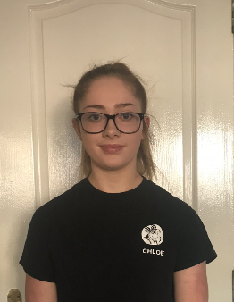
Chloe Phillips – Assistant Coach
Level 1 Women’s Artistic
Level 1 Floor & Vault Judge

OUR COMMITTEE MEMBERS

Claire Millar
Chairperson
Club Manager

Jill Elder
COVID Officer
Safeguarding Officer

Jen McRitchie
Treasurer/Accounts Officer

Lucy Phillips
Communications Officer

Suzanne Boyd-Thorpe
General Committee Member

